### **AUTROL-Shopping cart**

### *INTRODUCTION*:

Due to pandemic, customers have an overwhelming fear when they walk into a supermarket. Though retailers are doing their best to keep up with the increased needs for sanitisation, it can leave customers uneasy.

This approach may not be viable for long term and it is not a solution. People need to build trust that stores are a safe place to shop.In order to overcome this problem we are going to design an automatic shopping cart which is fully automated which can detect the products and sanitizes it thoroughly.

*PROBLEMS FACED IN CURRENT METHOD:*

1.Manual sanitisation miss spots and leave people exposed to viruses or bacteria.

2. Few markets do not follow safety standards which results in spread of viruses.

3. Some people do not have patience to stand in a queue and they rush into markets by neglecting the concept of social distancing.

4.Customers and employees sometimes do not wear masks which become a threat to many people.

5.Inspite of the restrictions to avoid Air Conditioner in the super markets some of them use and the viruses spread

easily.

*INTRODUCTION TO OUR SOLUTION:*

Food is the least of all the infectious agents. So, when it comes to the groceries, it’s the shopping and washing practices that we really need to focus on.

In order to solve this problem we use an automated shopping cart which uses image processing techniques to sense the product. The product that a customer needs to buy is selected using our smartphone or tablets and then it is communicated to the cart.It uses line follower commands for its mobility inside the shopping market, we introduce color based stops for the shopping cart to differentiate between rows inside the shopping market. Then inside the rows there will be an adjustable arm fixed with a camera at one end Which will image sense the products. Next after identifying the product which customer opted, the arm will grab the foremost product in the rack using a suction grabber and place it in a cardboard carton. Before placing in the cardboard carton there will be a scanner in the robo which will bill the product then and thereby using rfid. The carton shifts the products into a conveyor belt where the products are cleaned and sanitized.

Components Used:

Hardware:

1. Arduino:

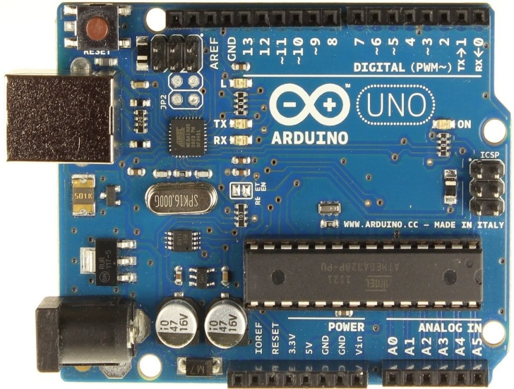

**Arduino** is an open-source electronics platform based on easy-to-use hardware and software. **Arduino** boards are able to read inputs - light on a sensor, a finger on a button, or a Twitter message - and turn it into an output - activating a motor, turning on an LED, publishing something online.

2.Raspberry Pi:

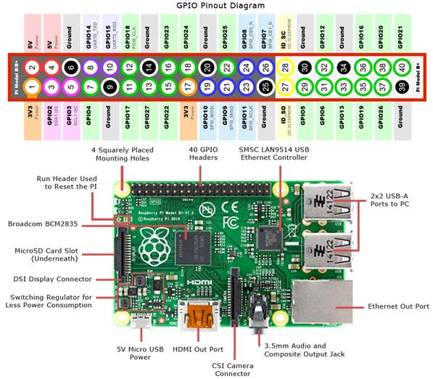

 A keyboard is connected to the **Raspberry pi** board to run the motor at different speeds by pressing the key. According to the program, the PWM (pulse width modulation) is caused at the output, and it can be programmed by using PHP/wiring **pi**.

1. Motors for Mobility:

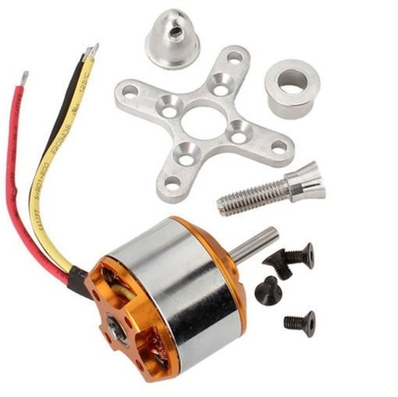

A **brushless** DC electric **motor** (BLDC **motor** or BL **motor**), also known as electronically commutated **motor** (ECM or EC **motor**) and synchronous DC **motors**, are synchronous **motors** powered by direct current (DC) electricity via an inverter or switching power supply which produces electricity in the form of alternating current.

1. Arms with suction pump:

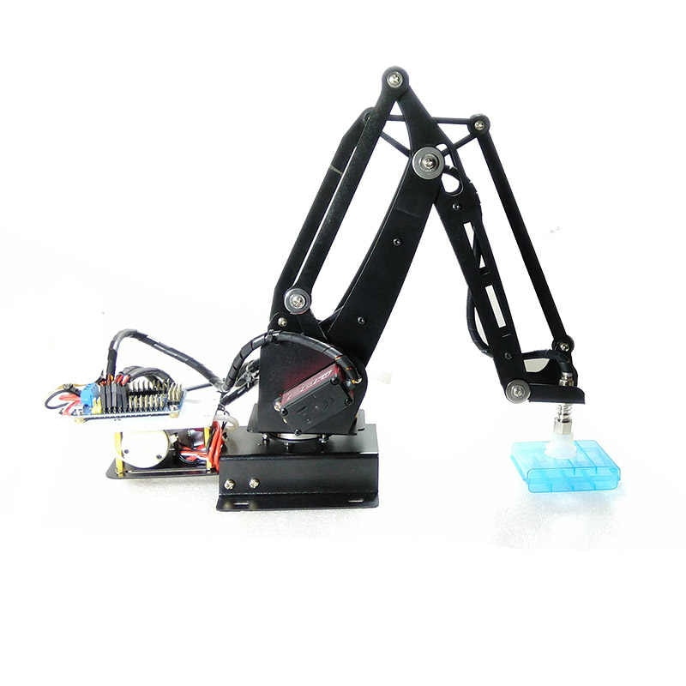

Arms with suction pump to grab a products in store. A **robotic arm** (not robotic hand) is a type of mechanical arm, usually programmable. In this robotic arm may be required to collect and stack items just as our one does.

Software:

1. Python(3.8.5):

The **Python** 3.8 series is the newest major release of the **Python** programming language, and it contains many new features and optimizations.

1. OpenCV(4.4.0)
2. Arduino code IDLE:

The **Arduino** Integrated Development Environment (**IDE**) is the main text editing program used for **Arduino** programming. It is where you'll be typing up your **code** before uploading it to the board you want to program. ... Essentially, the **IDE** translates and compiles your sketches into **code** that **Arduino** can understand.

Advantanges:

1. Gathering of people or crowd can be avoided
2. No touch interaction with people
3. It will be user friendly for people
4. Time and social distance between people can be maintained
5. Method of sanitizing will be done in proper methods